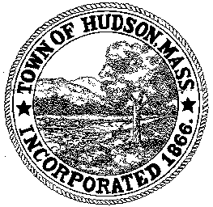

CONSERVATION COMMISSION
78 Main Street, Hudson, MA 01749
(978) 568-2020

Paul Byrne, Chairman W. Minot Wood, Vice Chairman David Esteves, Member

Terrence Joyce, Member Leif Longtine, Member Joseph Rodrigues, Member Al Tashian, Member

Agenda
July 16, 2009 7:00 P.M.

- Preliminaries
  - Open Meeting
  - Roll Call
1.3 Additions or Deletions to the agenda

2.0 Hearings and Appointments
2.1 DEP 190-542
Applicant: Rebecca Mattison
Location: 277 Chestnut Street
Project Description: The construction of an addition and deck at the rear of the house.

3.0 General Business
3.1 DEP 190-477
Erica Bigelow et al: request for Extenison
WPA 310 CMR 10.00
10.05 (8) “The issuing authority may extend an Order for one or more periods of up to three years each, which shall be made on Form 7. The request for an extension shall be made to the issuing authority at least 30 days prior to expiration of the Order”.

3.2 Request for Review and Comments
481 Main Street

3.3 Sign Voucher 063109 $1816.60
3.4 Sign Voucher 06071009 $657.00

4.0 Correspondence/Discussion

5.0 Adjournment

